

**LAB 4 Report**

**Course Name:** Machine Learning

**Course Code:** CSE-475

**Lab Name: YOLOv8-Based Underwater Plastic Detection**

# Submitted By

Name: Md Sanwarul Islam

ID: 2021-2-60-021

Dept. of Computer Science & Engineering

# Submitted To

Dr Raihan Ul Islam,

Associate Professor,

Department of Computer Science and Engineering

East West University

YOLO-Based Underwater Plastic Detection

## Abstract

This report explores the implementation of a YOLOv8-based object detection system for identifying underwater plastic waste. The system encompasses training, validation, prediction, and deployment of the model. The methodology leverages advanced computer vision techniques to address the critical environmental issue of underwater pollution. This paper presents the system design, experimental results, and potential applications while highlighting its strengths and limitations.

## 1. Introduction

Underwater plastic pollution is a significant environmental challenge, affecting marine ecosystems and biodiversity. Detecting and quantifying underwater plastic waste is essential for mitigation efforts. In this study, we present a YOLOv8-based object detection system tailored for underwater plastic detection. The system is designed to identify and localize plastic debris in underwater environments using a custom dataset and modern deep learning techniques.

## 2. Methodology

### 2.1 Dataset

The dataset comprises images of underwater scenes marred by discarded garbage and debris polluting the oceans. To enhance detection accuracy, a preprocessing method known as Dark Prior Channel was employed to amplify image contrast. The file structure is organized into three primary directories:

* **Train Directory:** Contains 3,628 images along with their associated labels.
* **Valid Directory:** Comprises 1,001 images paired with their respective labels.
* **Test Directory:** Encompasses 501 images along with their labels.

Each label file includes bounding box coordinates (e.g., x-coordinate of the top-left corner, y-coordinate of the top-left corner, width, height) and a class label. The dataset includes 15 distinct classes representing various types of underwater debris and objects:

1. **Mask:** Discarded face masks, common in oceans.
2. **Can:** Aluminum or metal cans contributing to water pollution.
3. **Cellphone:** Electronic waste from broken or discarded cell phones underwater.
4. **Electronics:** General category for gadgets like chargers, headphones, and other devices discarded in oceans.
5. **GBottle (Glass Bottle):** Glass bottles that can harm marine life due to sharp edges and long degradation periods.
6. **Glove:** Disposable gloves that add to underwater pollution from medical or industrial waste.
7. **Metal:** Miscellaneous metal objects like tools, wires, and metallic scraps found in water bodies.
8. **Misc:** Other miscellaneous pollutants that do not fit into specific categories.
9. **Net:** Fishing nets discarded or lost in oceans, posing entanglement risks to marine animals.
10. **PBag (Plastic Bag):** Plastic bags, a prevalent underwater pollutant affecting marine ecosystems.
11. **PBottle (Plastic Bottle):** One of the most common underwater wastes, taking years to decompose.
12. **Plastic:** General category for various types of plastic waste, including packaging and wrappers.
13. **Rod:** Fishing rods or metal rods discarded in water bodies, contributing to pollution.
14. **Sunglasses:** Discarded sunglasses found underwater, representing another form of plastic pollution.
15. **Tire:** Non-biodegradable tires contributing to rubber pollution in underwater environments.

### 2.2 System Architecture

The proposed system utilizes the YOLOv8 Nano model, renowned for its balance between efficiency and accuracy, making it an ideal choice for real-time object detection tasks. The overall architecture of the system involves multiple stages, each contributing to the seamless operation of the detection pipeline. Below is a breakdown of the core components:

* **Data Preprocessing:** This step involves preparing the dataset by resizing images, enhancing contrast using the Dark Prior Channel method, and converting annotations to a YOLO-compatible format. Proper preprocessing ensures that the model receives optimized input for better detection performance.
* **Model Training:** The YOLOv8 Nano model is trained on the preprocessed dataset. This phase includes configuring various hyperparameters, such as learning rate and batch size, to achieve optimal results. The model learns to identify underwater plastics by minimizing error across multiple epochs.
* **Validation:** After training, the model is validated on a separate subset of the dataset to assess its performance. Metrics such as precision, recall, and mAP (mean Average Precision) are calculated to evaluate the effectiveness of the model in detecting underwater debris.
* **Prediction and Visualization:** Once validated, the trained model is used to predict objects in test images. The predictions are visualized by drawing bounding boxes around detected objects, along with their respective class labels and confidence scores. These visual outputs are essential for qualitative analysis.

### 2.3 Training Configuration

The training configuration plays a vital role in achieving optimal model performance. The following hyperparameters were carefully selected to balance efficiency and accuracy:

* **Model:** YOLOv8 Nano, chosen for its lightweight architecture, making it suitable for deployment on resource-constrained devices.
* **Hyperparameters:**

○ **Epochs:** The model was trained for 50 epochs to ensure sufficient exposure to the training data while avoiding overfitting.

○ **Batch Size:** A batch size of 16 was used to optimize memory usage and training speed.

○ **Learning Rate:** The initial learning rate was set to 0.001, enabling gradual convergence of the model weights.

○ **Image Size:** All images were resized to 640 pixels to standardize input size, improving model consistency.

○ **Weight Decay:** A weight decay of 0.0005 was applied to regularize the model and reduce overfitting.

○ **Augmentation:** Data augmentation techniques were employed to increase dataset variability and improve model robustness. These techniques included random rotations, flips, and color adjustments.

This configuration ensures that the YOLOv8n model can effectively learn to detect underwater plastics with high accuracy, even when faced with challenging underwater conditions.

## 3. Performance Evaluation

### 3.1 Training Metrics

The following metrics were calculated during model validation to assess its performance:

|  |  |  |
| --- | --- | --- |
| **MODEL : YOLOv8** | |  |
| **Metric** |  | **Value** |
| Precision | 0.7270 |  |
| Recall | 0.7127 |  |
| mAP@50 | 0.7595 |  |
| mAP@50-95 | 0.4978 |  |
| Accuracy | 0.7198 |  |

### 3.2 Prediction Outcomes

Predictions on test images revealed effective detection of underwater plastics. Bounding boxes accurately localized plastic debris with minimal false positives. Annotated images were saved for qualitative analysis.

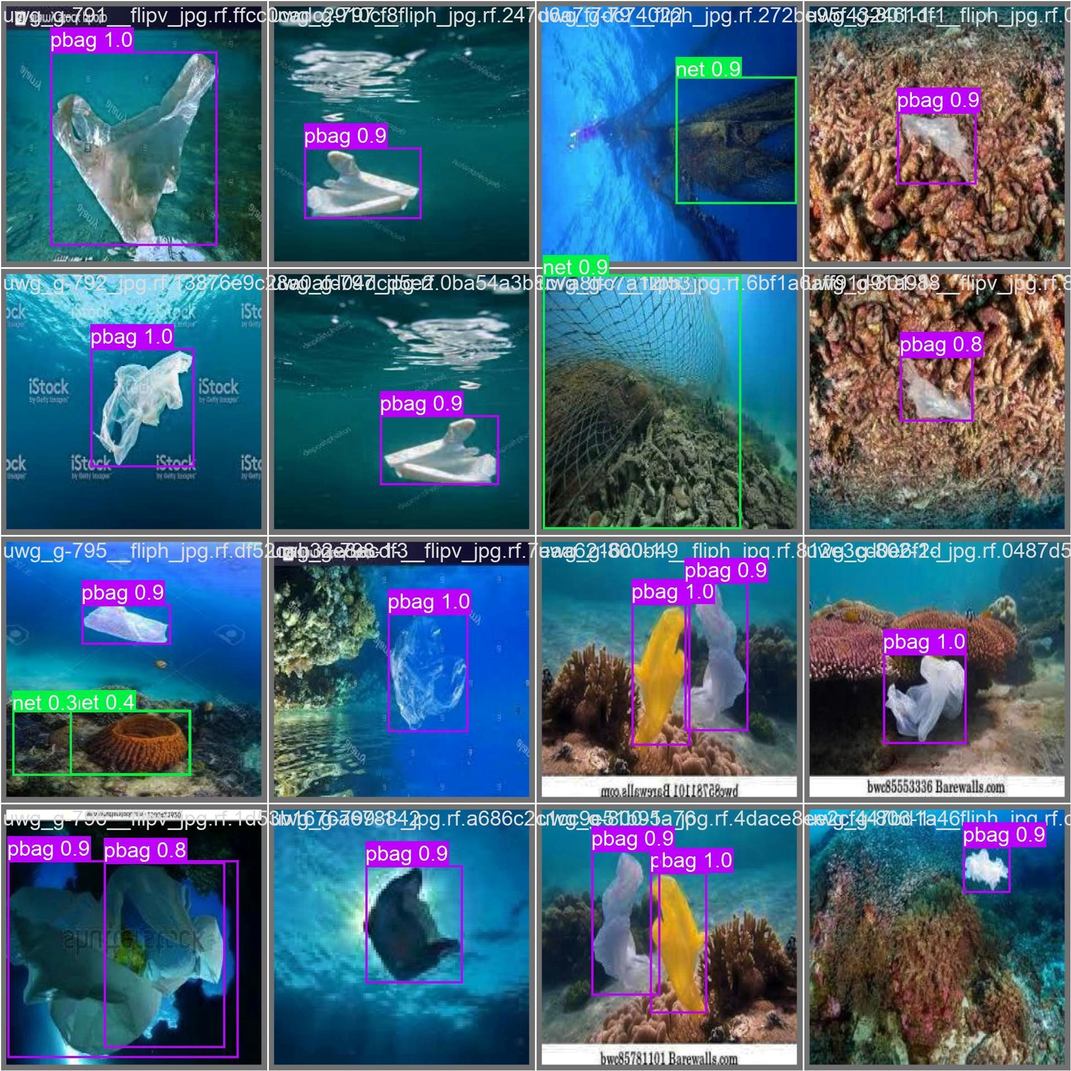

**Figure 1:** Annotated image showcasing bounding boxes and labels for detected plastic debris.

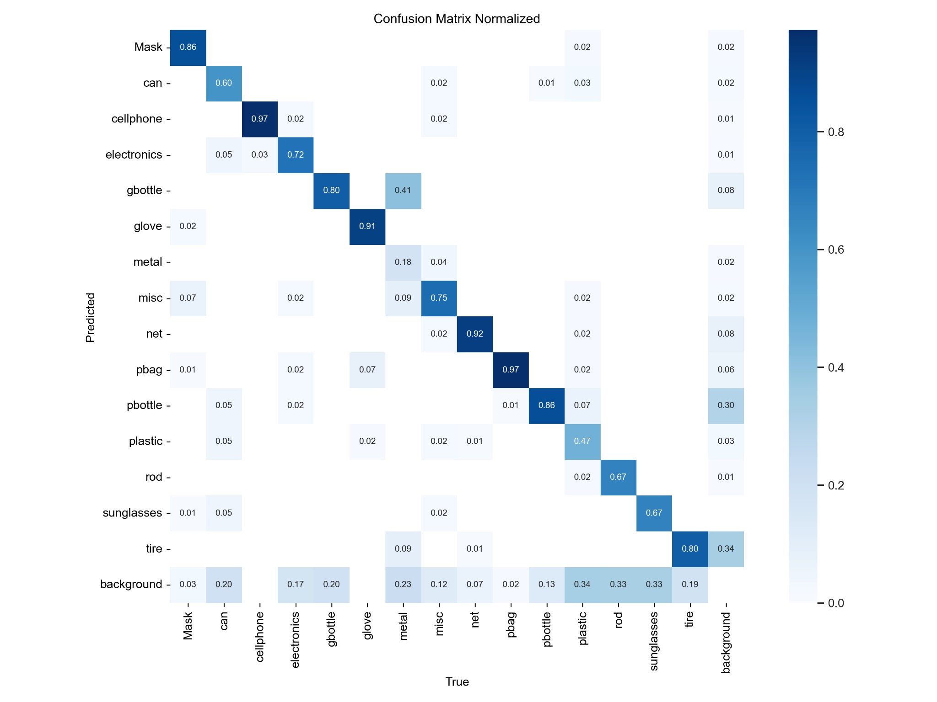

**Figure 2:**Confusion Matrix Normalized.

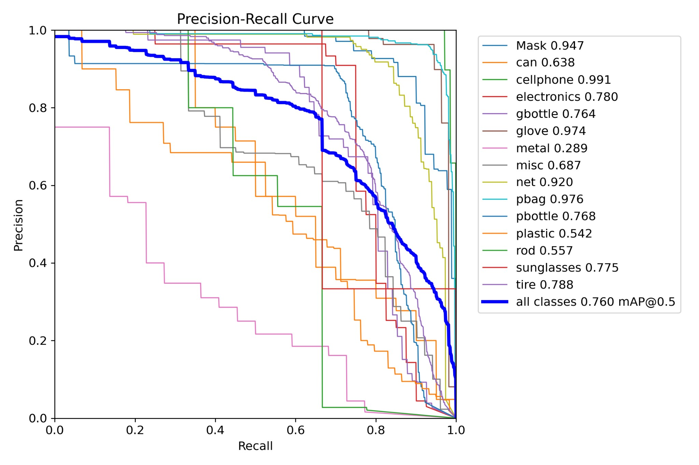

**Figure 3:** Precision-Recall curve demonstrating model performance across confidence thresholds.

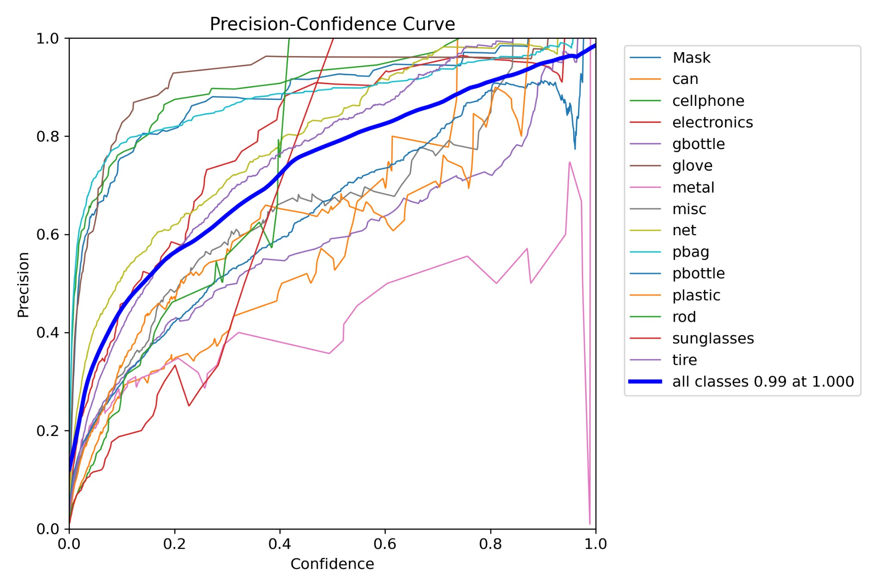

**Figure 4:** Precision-Confidence curve demonstrating model performance across confidence thresholds.

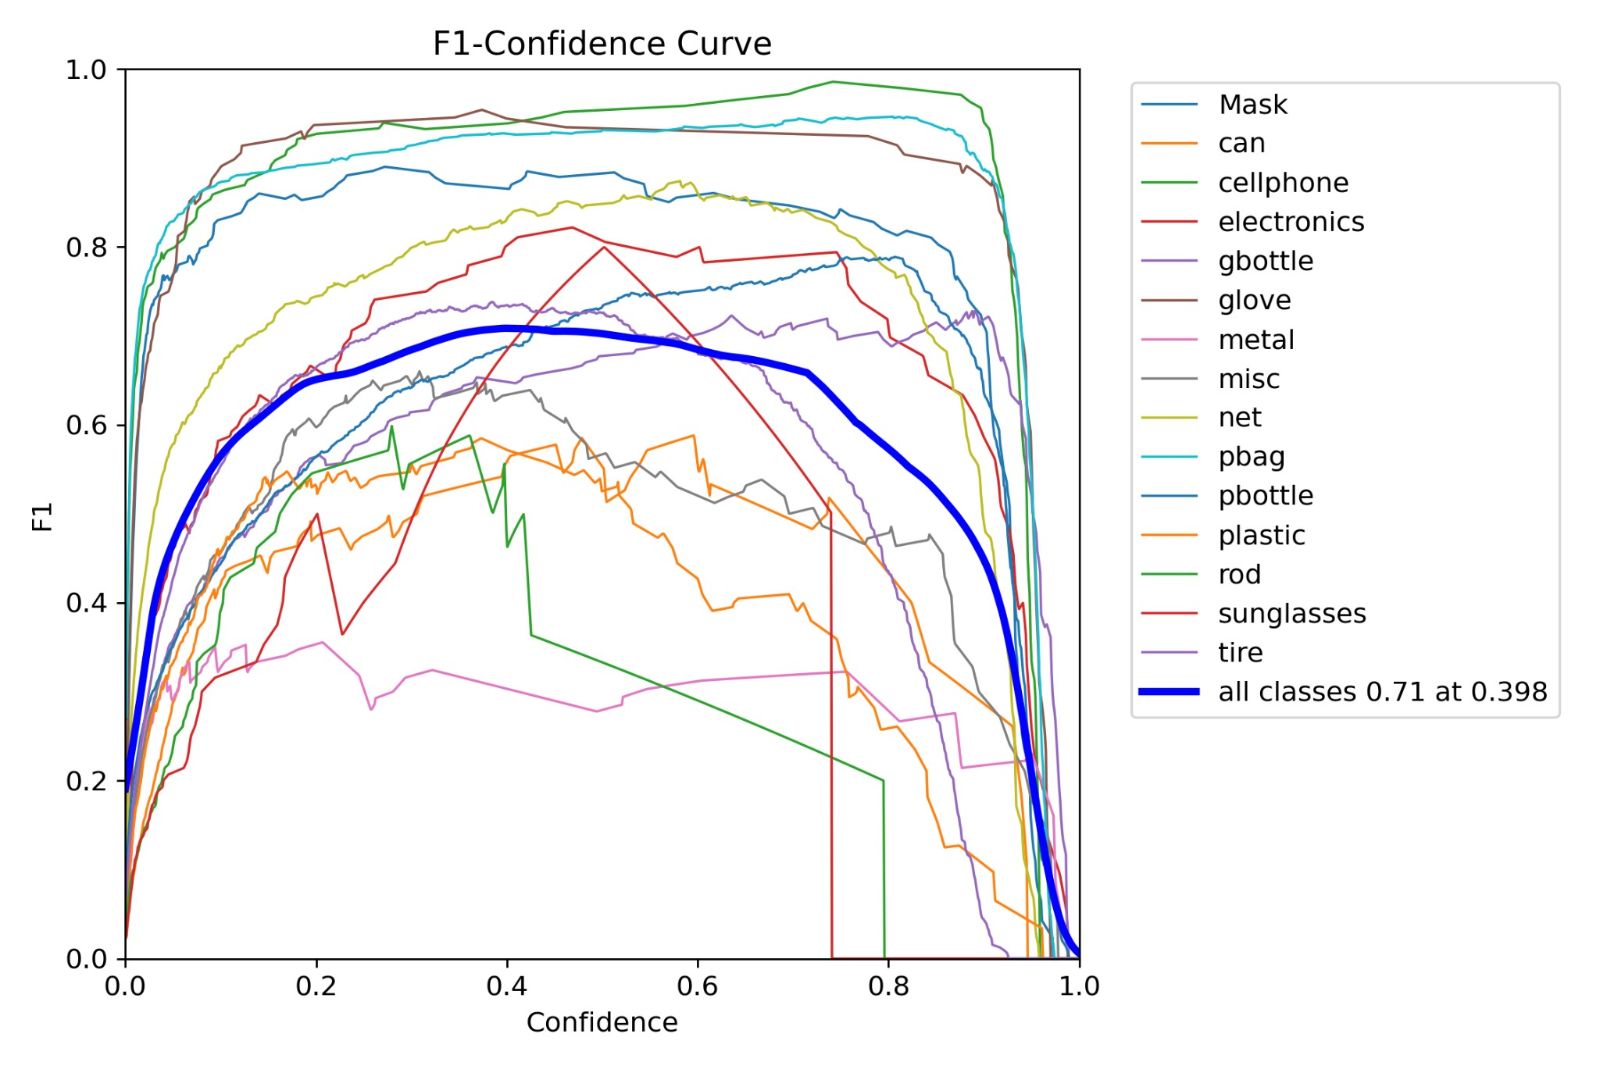

**Figure 5:** F1 -Confidence curve demonstrating model performance across confidence thresholds.

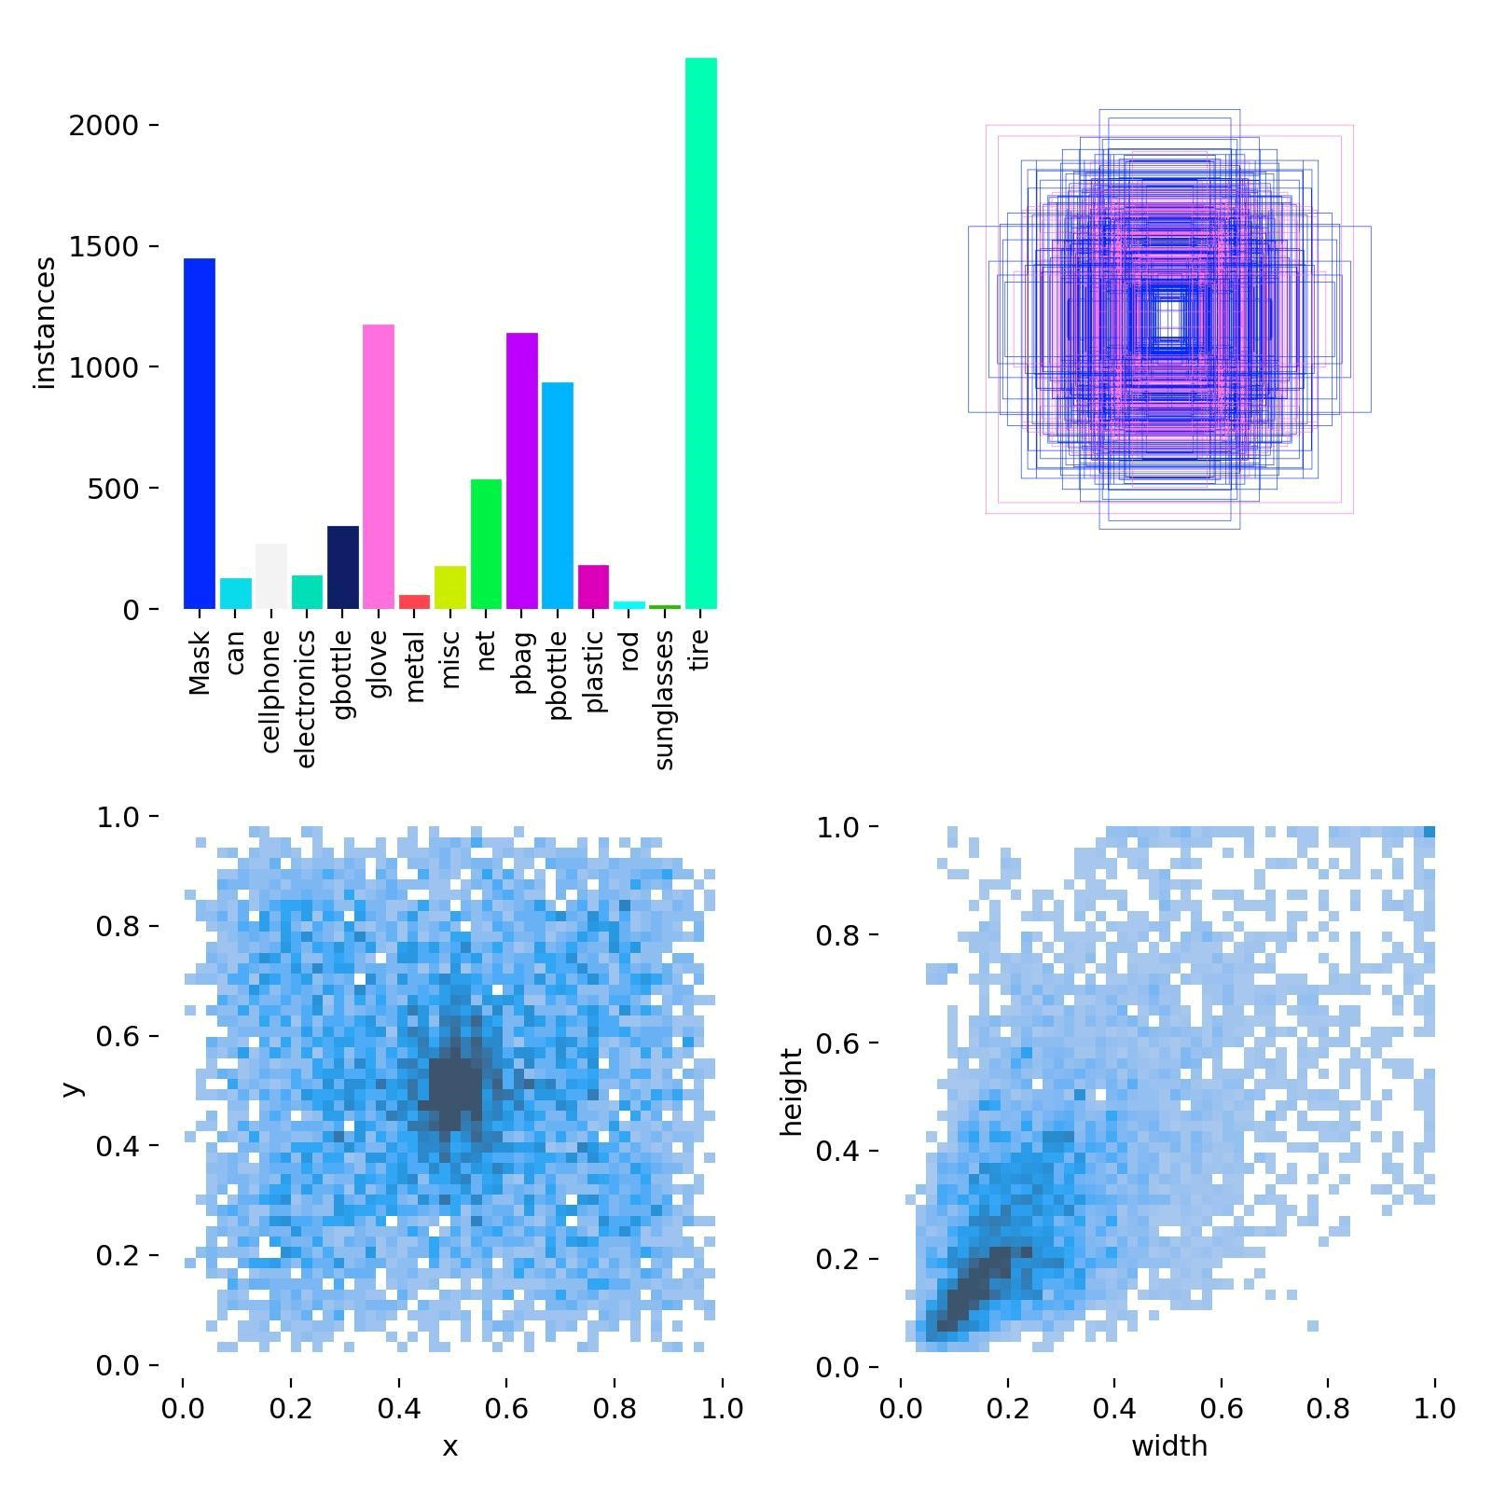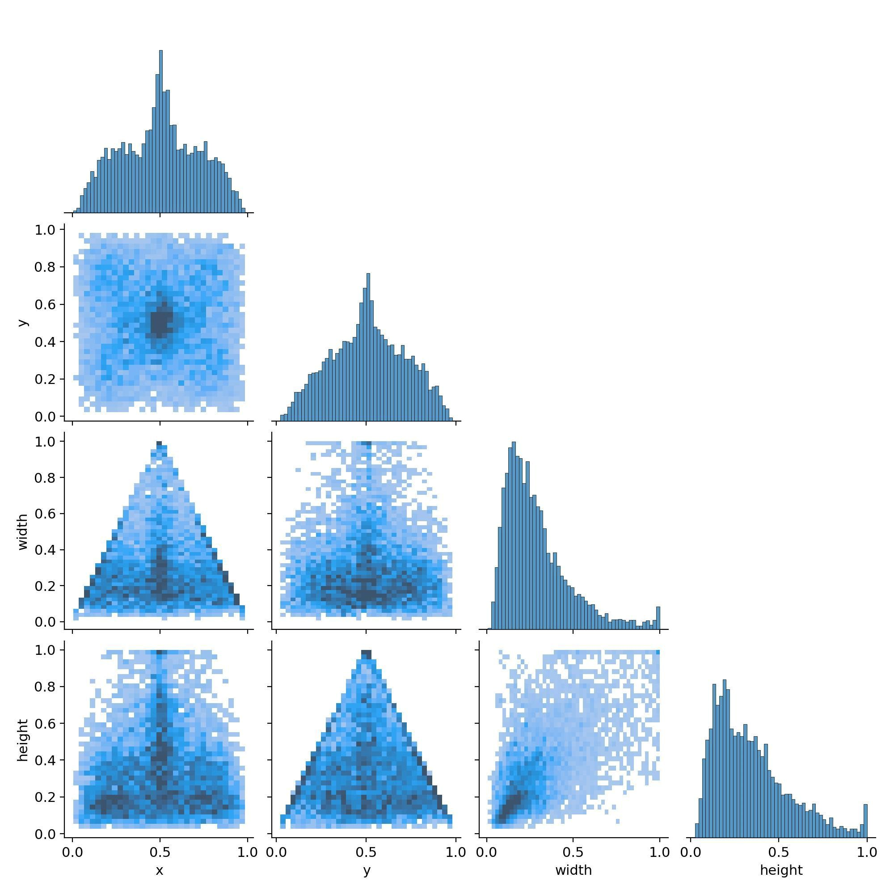

**Figure 6:** Labels demonstrating model performance across confidence thresholds.

## 4. Results

### 4.1 Visual Outputs

Annotated images were generated to illustrate detection performance, with bounding boxes accurately localizing various classes of underwater debris.

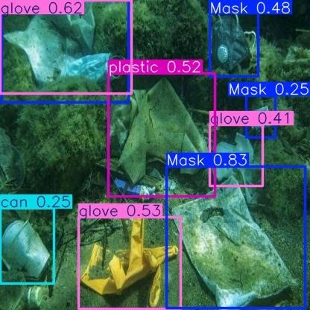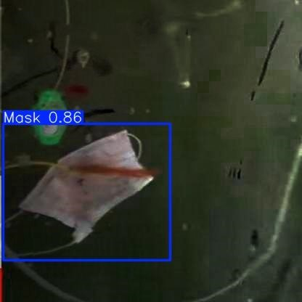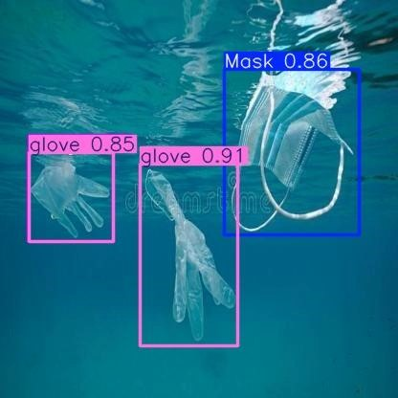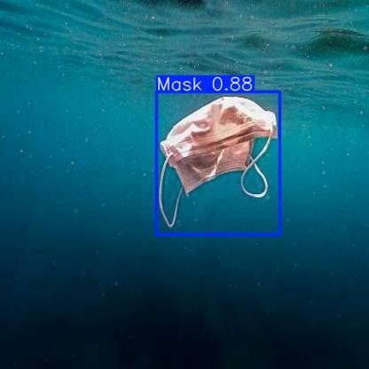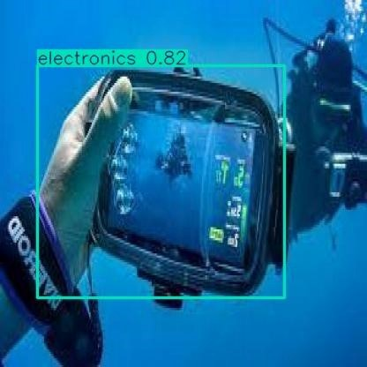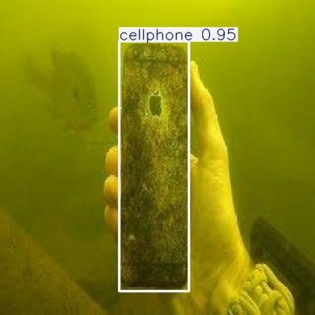

**Figure 7:** Visuals demonstrating model detection of underwater object detection.

# 5. Discussion

The proposed system demonstrates several strengths that make it a viable solution for underwater plastic detection. One of its key strengths is the efficient and accurate detection capability provided by the YOLOv8 Nano model. The comprehensive pipeline, which spans from training to deployment, ensures a complete end-to-end solution. The visualization of bounding boxes and confidence scores is user-friendly, making it easier for users to interpret the detection results. Additionally, GPU acceleration significantly enhances the speed of training and inference processes. Despite these strengths, the system has several limitations. The model's generalizability is restricted due to the dataset's limited diversity, which could hinder its performance in different underwater environments. Furthermore, the hyperparameters used in the training process are static, which may not yield optimal results for all datasets. The system also requires manual creation of directories for storing dataset and results, which could be cumbersome for users. To address these limitations, several recommendations for future work have been proposed. Implementing dynamic hyperparameter optimization could enhance the model's performance across various datasets. Expanding the dataset to include more diverse underwater environments would improve the model's generalizability. Integrating real-time detection capabilities would make the system more practical for field applications. Finally, developing a comprehensive logging system would help in tracking the model's training progress and performance metrics more effectively.

## 6. Conclusion

The proposed YOLOv8-based system demonstrates an effective approach to underwater plastic detection. While it shows promise in addressing underwater pollution, future improvements in adaptability and scalability are essential for broader applications. This study underscores the potential of AI-driven solutions in environmental conservation efforts.